
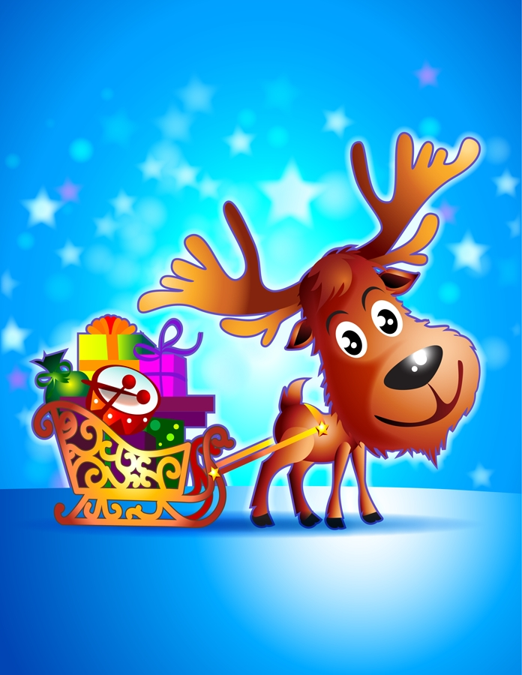
Bligh’s Lane Nursery School

Christmas Newsletter 2022

MONTHLY THEME
The Theme for this month is Christmas. Talk to your child about the Nativity story and help them to learn the songs that you know – especially the first verse of Away in a Manger, as it is very difficult for young children.

SONGS AND RHYMES

Nativity songs | Christmas Songs
- Here we go up to Bethlehem | - Jingle Bells
- I was there on the night when Jesus came | - When Santa got stuck up the Chimney
- Away in a manger | - Santa Claus is coming to town
- Follow the Star | - Silly Santa Song
- Angel Gabriel’s Song | - Christmas Star
 | - Father Christmas

NATIVITY PLAYS
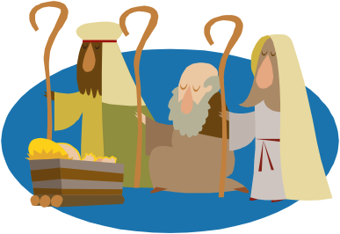
The children perform a very simple Nativity Play each year. We do two performances on each day to make the seating arrangements more comfortable. The performance dates and times are:

THURSDAY 8th DECEMBER: Mrs Woods’/Mrs Doherty’s Class

9.15 am Blue Group 10.00 am Red Group

FRIDAY 9th DECEMBER: Mrs O’ Doherty’s Class

9.15 am Yellow Group 10.00 am Green Group

The Children will get opportunities to try out the different Nativity parts during the weeks leading up to Christmas, and we need parents to understand that every part in the play is important because every child is important. Some children will have a few words to say and it is important to remember that some children are comfortable talking in front of others and some are not – we do not want to upset any child so each child must be happy with their own part. We hold the play early in the morning before the children become tired and it usually lasts about 15 or 20 minutes at most.
Each child will be given two tickets for the play. These can be used by parents, grandparents etc but are we are strictly limiting to two adults per child due to the risk still posed by Covid 19. We do ask that other children are not brought to the Nativity plays as this has proved to be very distracting for our small children in the past. It is essential that the children are at school every day now unless they are very sick, as we will be learning the Nativity songs and talking about the play. Cameras are allowed since all parents have signed their consent for photographs/videos to be taken of the Nativity Plays.

We have all the costumes required for each child. However, we ask for parents to dress their children in either plain white or dark clothing depending on their part. We will let you know soon what colour your child should wear.

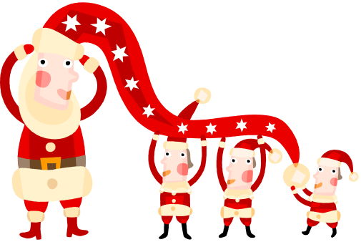
Santa Claus will visit the school on Wednesday 21st December during class times and each child will receive a gift. Classes will go separately to the multi-purpose room for Santa’s visit and the children go up to see him one by one (If you think your child will be afraid of Santa, let us know so that we can seat him/her further away – if a child doesn’t want to go up to Santa, he hands the child his/her present from a safe distance!). We will take a photograph of every child with Santa.
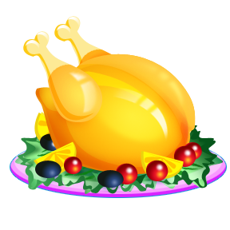
CHRISTMAS DINNER
The children will have ‘Christmas Dinner’ in school with all the trimmings on Thursday 8th December. It always goes down a treat!

ST. VINCENT DE PAUL SOCIETY APPEAL
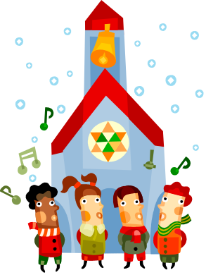
During the Christmas season we help the children to understand the importance of giving rather than receiving. There has been a tradition in the school each year that the parents bring items of groceries, toiletries, small toys, books or clothes etc. to donate to needy families on behalf of the families in the school. Parents have always been generous but we understand that this year there is unprecedented financial pressure on families. Please DO NOT feel obliged to donate. If you are in a position to do so please bring what you can into school as soon as you can and before Thursday 15th December. We will take what has been collected to St Mary’s Chapel on Tuesday 20th December. The staff will walk up to the Divine Mercy Chapel (at St.Mary’s) with the children. A priest from the parish and a representative from the St Vincent De Paul Society welcome the children, each child then leaves a small ‘gift’ (i.e. something that you have brought in) in front of the crib and we all sing our Nativity songs. Parents / grandparents are welcome to attend this little ceremony, which will begin at 12.50pm, and then all children should be collected from the Chapel by 1.15pm.

We again remind you that our staff are not expecting Christmas gifts from children. We know that times are difficult for many families and ask that you spend your money on your own families or donate to a charity that will help those in severe hardship.

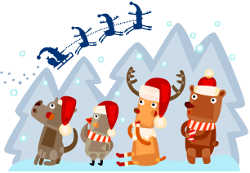
ELF ON THE SHELF
Santa has sent an Elf to each room in Bligh’s Lane Nursery School. The Elf will be watching the children and reporting back to Santa every day. The Elf hides in different places each day, they could be in the class, cloakroom, playground- the children need to be on their best behaviour EVERYWHERE!

EXTENDED SCHOOLS PROGRAMME
We have had a very positive response with regard to this programme from children and parents. The children seem to be getting a lot of enjoyment and learning from the different sessions. The Extended Schools programme will not run in December, as we will be very busy with Christmas preparation. We look forward to starting the program again in January when Mrs Woods/Doherty’s class will resume on the 9th January.

VISIT TO CREGGAN LIBRARY
The children will visit Creggan Library to hear some Christmas stories on the following dates:

-Mrs Woods/Doherty’s Class: Monday 14th December

-Mrs O’ Doherty’s Class: Wednesday 16th December


VISIT TO SANTA AT THE PLAYTRAIL
The children will visit “Santa at the Playtrail” on Tuesday 13th December (Room 1) and Thursday 15th (Room 2). Please let us know if your child is a bit wary of Father Christmas and we will make sure they are seated next to an adult during the session.

NURSERY AND PRIMARY APPLICATIONS FOR SEPTEMBER 2023
If you have (or know of) a child due to start Nursery in September 2023 i.e. 3 years old on or before 2nd July 2023 please ask them to keep an eye on the Education Authority website (https://www.eani.org.uk/) or Facebook page. ALL APPLICATIONS MUST BE MADE ONLINE. The application window opens at 12 noon on Tuesday 10th January and remains open until Friday 27th January at 12 noon.

BIG BEDTIME READ
We have had a very successful start to our Big Bedtime Read initiative with the large majority of families borrowing reading packs regularly. We will continue to lend the packs during December but ask for all packs to be returned on the 9th December. We will resume lending on the 6th January 2022.

ECO-SCHOOLS AWARD
We are continuing on our journey for eco-school green status before the end of the year. The children are learning so much about looking after our environment. They have been fantastic Eco warriors- please keep encouraging them at home to recycle.

REMINDER
Please DO NOT allow your children to play on the walls or go into the planting bed area (near the gates) after school. Children need to be accompanied by a member of staff to enter this area. Thank you for your cooperation.


LAST DAY OF TERM AND CHRISTMAS HOLIDAYS
Wednesday 21st December will be the last day of term. The children should be collected at 11.30 am. on this day. They will have school dinner before pick up time.

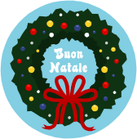
We will see you all again on Wednesday 4th January 2023.

The staff would like to thank all our parents for their support to date and to wish you all a very Merry Christmas! We have had a lovely term with all of the children and we have seen so much progress already.

DECEMBER BIRTHDAYS

- Misha Momodu
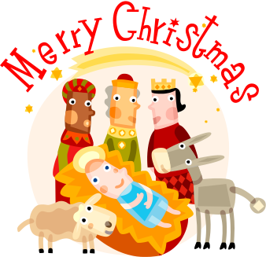
- Noah Bradley Healy
- James McCallion

